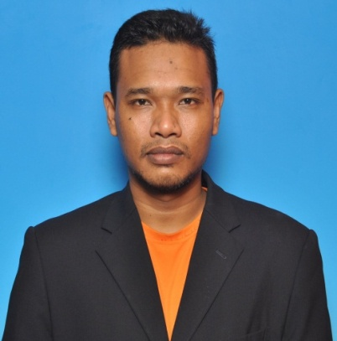

**MOHD AZFAR BIN ARIFF**

|  |
| --- |
| **Contact Information** |

**Address :** Lot 620 Jalan Tegas Kampung Padang Jawa 40200 Shah Alam Selangor.

**Mobile Number :**  018 - 2550966

**Email : azfa_boy@yahoo.com.my** *(Please e-mail or sms if my mobile number*

*cannot be reached)*

|  |
| --- |
| **Personal Particulars** |

**Age :** 30 years old  **Date of Birth :** 19th OCT 1984

**Nationality :** Malaysian **Gender :** Male

**Marital Status :** Single **IC No. :** 841019-01-5269

|  |
| --- |
| **Employment History** |

**1.Company Name : Propel Network Sdn Bhd**

**Position : Network Driver Test**

**Specialization :** Computer

**Industry :** Information Technology

**Date Joined :** 2013

**Reason Of Leaving :** Contract - Completion of service (1 year)

**2.Company Name : PUSAT TEKNOLOGI & PENGURUSAN LANJUTAN (PTPL)**

**Position :** Technician

**Specialization :** Computer

**Industry :** Information Technology

**Date Joined :** 2010

**Reason Of Leaving :** Improve my knowledge in new environment

**3.Company Name : Nestle (M) Berhad**

**Position :** Forklift Driver

**Specialization :** Warehouse

**Industry :** Food Manufacturing

**Date Joined :** 2006

**Reason Of Leaving :** Futher study at POLISAS, Kuantan, Pahang

|  |
| --- |
| **Educational Background** |

**Higher Education**

**1. Level :** Diploma in Electronics Engineering

**Field of Study :** Electonics Computer

**CGPA : 2.27/4.0**

**Institute/University :** Politeknik Sultan Haji Ahmad Shah

**Located In :** Kuantan, Pahang

**Graduation Date :** May 2010

**2. Level :**Certificate of System computer and support

**Field of Study :** Basic Computer

**CGPA : 3.00/4.0**

**Institute/University :** Kolej Komuniti Segamat

**Located In :** Segamat, Johor

**Graduation Date :** June 2006

**Secondary Education**

**1.Level :** Sijil Pelajaran Malaysia

**Field of Study :** Sastera

**Grade : OPEN**

**School :** Sek.Men.Kebangsaan Anjung Batu Mersing

**Located In :** Mersing, Johor

**Graduation Date :** December 2001

**2. Level :** Penilaian Menengah Rendah

**Field of Study :** Standard

**Grade : 1B 2E 4D 1C**

**School :** Sekolah Menengah Seksyen 16 Shah Alam

|  |
| --- |
| **Technical Skills** |

**Skill Proficiency**

TYPING Advanced

MICROSOFT OFFICE Advanced

INTERNET EXPLORER Advanced

POWER POINT Advanced

MICROSOFT EXCEL Advanced

|  |
| --- |
| **Languages** |

**Proficiency** (0=Poor - 10=Excellent)

**Language Spoken Written Proficiency**

Bahasa Malaysia Advance Advance 10

English Moderate Moderate 8

|  |
| --- |
| **Additional Information** |

**PERSONAL CHARACTER:**

I am a disciplined individual, interested to explore the challenges in the real working environment. I work well independently as well as also a team player; where my strong problem solving problem and planning skills will come handy. I am a fast learner and would be happy to gain experience as well as to share my own experiences to improve working relationship in the workplace.

**STRENGTHS:**

* Ability to work in a team environment or even independently
* Love challenges and willing to learn
* Adapt and learn fast
* Social able and outgoing
* Best in Customer Service

**SIGNIFICANT COURSEWORK:**   
PC Maintenance (pc and printer repairing), Troubleshoot pc, Network, manage and setup pc for some event like examination preparation, release examination slip and others

Managing IT helpdesk and answering phone call and other related computer work

**Expected Monthly Salary :** RM 1800.00

**Availability :** Immediately

|  |
| --- |
| REFEREES |

OMAR BIN YADI

**(NETWORK SUPERVISOR)**

**MANAGEMENT & SCIENCES UNIVERSITY (MSU)**

UNIVERSITY DRIVE, OFF PERSIARAN OLAHRAGA,

SECTION 13,

40100 SHAH ALAM, SELANGOR DARUL EHSAN.

603-55216868 FAX 603-55112848

016-2730688

Zulhilmi bin Ibrahim

Office mate (IT Technician)

**MANAGEMENT & SCIENCES UNIVERSITY (MSU)**

UNIVERSITY DRIVE, OFF PERSIARAN OLAHRAGA,

SECTION 13,

40100 SHAH ALAM, SELANGOR DARUL EHSAN.

603-55216868 FAX 603-55112848

016-3914033